1. Ingredient Inventory Management
Scenario: The kitchen manager needs to know how many unique recipes use "Chicken" to plan bulk purchasing.
- Interpretation: This requires a simple COUNT with a WHERE filter on the normalized Recipe_Ingredients table.
- 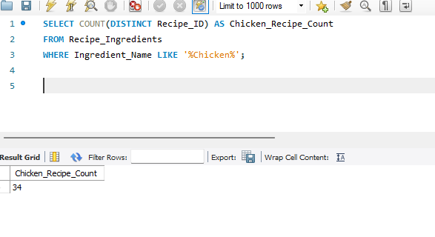
SQL
SELECT COUNT(DISTINCT Recipe_ID) AS Chicken_Recipe_Count
FROM Recipe_Ingredients
WHERE Ingredient_Name LIKE '%Chicken%';
- Explanation: Using LIKE with wildcards ensures we catch "Chicken Breast" or "Chicken Wings".
2. Low-Stock "Quick Fix" Meals
Scenario: A user has very little time and needs a recipe that takes less than 20 minutes and requires 4 or fewer ingredients.
- Interpretation: This involves a JOIN between Recipes and a subquery that counts ingredients per recipe.
- SQL
SELECT r.Recipe_Name, r.Cooking_Time_Mins
FROM Recipes r JOIN (SELECT Recipe_ID, COUNT(*) AS ItemCount
FROM Recipe_Ingredients GROUP BY Recipe_ID) i
ON r.Recipe_ID = i.Recipe_ID WHERE r.Cooking_Time_Mins < 20 AND i.ItemCount <= 4;
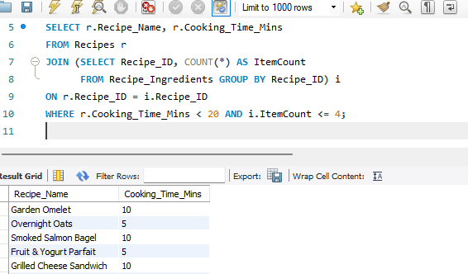

Explanation: This demonstrates the ability to perform calculations on one table and filter based on another.

3. High-Value Menu Analysis
Scenario: Identify the "Premium" recipes—those priced above $20.00—and show their average rating to see if customers feel they are getting their money's worth.
- Interpretation: This uses AVG and GROUP BY to correlate pricing tiers with satisfaction.
- Query:
SQL
SELECT Recipe_Name, Price_USD, Rating
FROM Recipes
WHERE Price_USD > 20.00
ORDER BY Rating DESC;

- Explanation: Helps a restaurant owner decide if expensive items should stay on the menu based on quality.
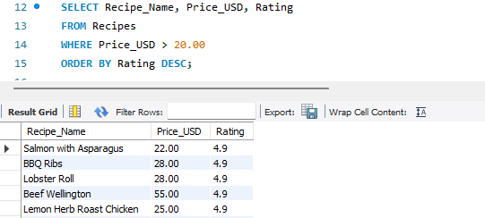

4. Identifying "Data Gaps" (Audit)
Scenario: The system administrator needs to find any recipes that were created but haven't had their nutritional information entered yet.
- Interpretation: This requires a LEFT JOIN to find records in the parent table that have no match in the child table.
- Query:
SQL
SELECT r.Recipe_Name
FROM Recipes r
LEFT JOIN Nutrition n ON r.Recipe_ID = n.Recipe_ID
WHERE n.Recipe_ID IS NULL;
- Explanation: This is a standard "Null Check" to ensure data completeness across a normalized database.
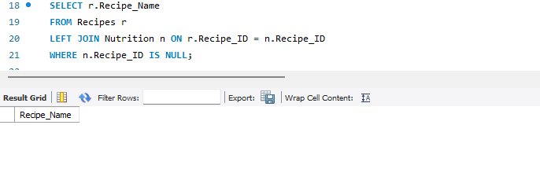
5. Most Popular "Efficiency" Recipes
Scenario: Find recipes that have a higher-than-average rating but take less time than the average cooking time of all recipes.
- Interpretation: Uses multiple scalar subqueries to compare individual rows against global averages.
- Query:
SQL
SELECT Recipe_Name, Rating, Cooking_Time_Mins
FROM Recipes
WHERE Rating > (SELECT AVG(Rating) FROM Recipes)
AND Cooking_Time_Mins < (SELECT AVG(Cooking_Time_Mins) FROM Recipes);
- Explanation: This identifies "high-ROI" recipes for busy users—maximum flavor for minimum time.

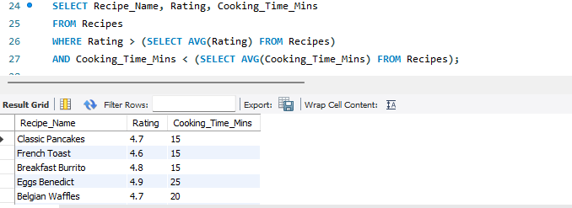

6. Automating Frequent Searches (Views)
Scenario: The front-end developers keep asking for the "Top 10 Best Rated" list. Instead of them writing complex SQL, create a virtual table they can just select from.
- Interpretation: Demonstrates the use of a VIEW for security and simplicity.
- Query:
SQL
CREATE VIEW Top_10_Best_Rated AS
SELECT
Recipe_ID,
Recipe_Name,
Rating,
Review_Count,
Price_USD
FROM Recipes
ORDER BY Rating DESC, Review_Count DESC
LIMIT 10;

SELECT * FROM Top_10_Best_Rated;
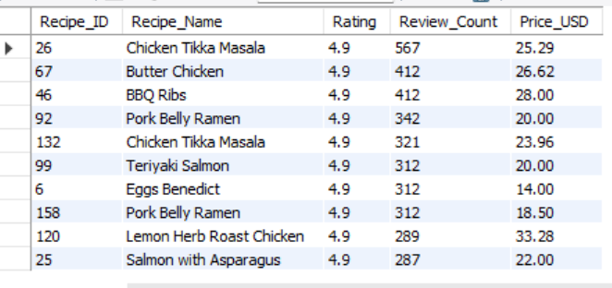

- Explanation: A View simplifies the interface for other developers and hides the underlying logic.

7. Preventing "Garbage Data" (Constraints)
Scenario: Management wants to ensure that no one accidentally enters a recipe with a negative price or a rating higher than 5.
- Interpretation: This uses CHECK constraints to enforce business rules at the database level.
- Query:
SQL
ALTER TABLE Recipes
ADD CONSTRAINT chk_Rating CHECK (Rating >= 0 AND Rating <= 5),
ADD CONSTRAINT chk_Price CHECK (Price_USD >= 0);
- Explanation: Constraints ensure data integrity so the application doesn't crash due to invalid input.
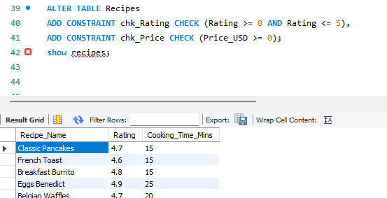

8. Analyzing Yearly Content Growth
Scenario: The platform started in 2023. How many recipes were added in 2024 specifically?
- Interpretation: Filtering by date ranges or using date functions on a DATETIME column.
- Query:

SELECT COUNT(*) AS Recipes_Added_2024
FROM Recipes
WHERE YEAR(Creation_Timestamp) = 2024;
- Explanation: Essential for reporting on business growth and user activity over time.

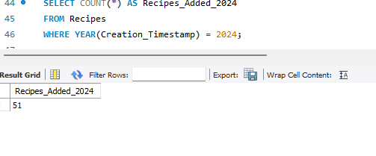

9. Recipes With Same Cooking Time
Scenario: Find recipes having identical cooking times.
Interpretation: Self-join.
Query:
SELECT r1.Recipe_Name, r2.Recipe_Name, r1.Cooking_Time_Mins
FROM Recipes r1
JOIN Recipes r2
ON r1.Cooking_Time_Mins = r2.Cooking_Time_Mins
AND r1.Recipe_ID <> r2.Recipe_ID;
Explanation: Finds duplicate values across rows.

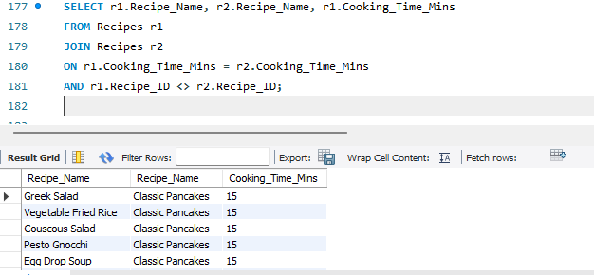

10. Multi-Criteria Search (Complexity)
Scenario: A user wants a "Vegetarian-friendly" breakfast. Find recipes that do not contain "Beef", "Chicken", or "Pork" and are tagged with a breakfast-related timestamp (morning).
- Interpretation: Using NOT IN or NOT LIKE combined with complex WHERE logic.
- Query:
SQL
SELECT DISTINCT r.Recipe_Name
FROM Recipes r
WHERE r.Recipe_ID NOT IN (
SELECT Recipe_ID FROM Recipe_Ingredients
WHERE Ingredient_Name IN ('Beef', 'Chicken', 'Pork', 'Lamb')
)
AND HOUR(r.Creation_Timestamp) BETWEEN 5 AND 11;

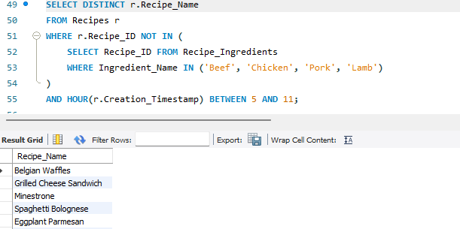

11. Dynamic Menu Labels (CONCAT & Comparison)
Scenario: The UI needs a "Price Tag" display that combines the recipe name and its price with a currency symbol, but only for items cheaper than $15.00.
- Interpretation: Uses CONCAT for string manipulation and comparison operators for filtering.
- Query:
SQL
SELECT CONCAT(Recipe_Name, ' - $', Price_USD) AS Price_Tag
FROM Recipes
WHERE Price_USD < 15.00;
- Explanation: This formats data directly in the database to reduce the processing load on the application's front-end.

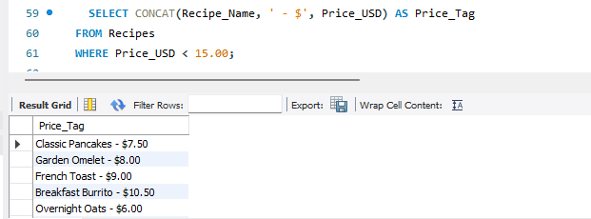

12. Seasonal Price Update (UPDATE Command)
Scenario: Due to a seasonal increase in ingredient costs, the manager wants to increase the price of all "Salmon" dishes by 10%.
- Interpretation: Demonstrates data modification using the UPDATE command with a WHERE clause.
SQL
UPDATE Recipes
SET Price_USD = Price_USD * 1.10
WHERE Recipe_Name LIKE '%Salmon%';
- Explanation: Shows how to perform bulk updates safely without affecting the entire table.
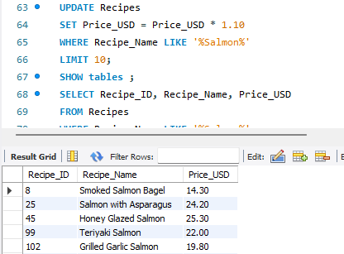

13. High-Protein Benchmark (Correlated Subquery)
Scenario: Find recipes that provide more protein than the average protein content of other recipes in the same calorie range.
- Interpretation: A correlated subquery where the inner query depends on the value of the outer query.
SQL
SELECT r.Recipe_Name, n1.Protein_g
FROM Recipes r
JOIN Nutrition n1 ON r.Recipe_ID = n1.Recipe_ID
WHERE n1.Protein_g > (
SELECT AVG(n2.Protein_g)
FROM Nutrition n2
WHERE n2.Calories_kcal BETWEEN n1.Calories_kcal - 50 AND n1.Calories_kcal + 50
); [cite: 17, 40]
- Explanation: This is a sophisticated analytical query that compares a row against a specific "peer group" rather than the whole table.

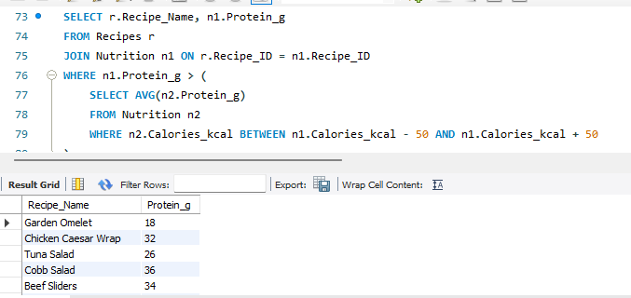
14. Speeding Up Search (Indexes)
Scenario: The app is lagging when users search for recipes by name. How do you optimize this?
- Interpretation: Implementing a B-Tree Index to improve retrieval speed.
- Query:
SQL
CREATE INDEX idx_recipe_name ON Recipes(Recipe_Name);
- Explanation: Indexes allow the database to find rows without scanning every single record, which is vital as the Recipes table grows.
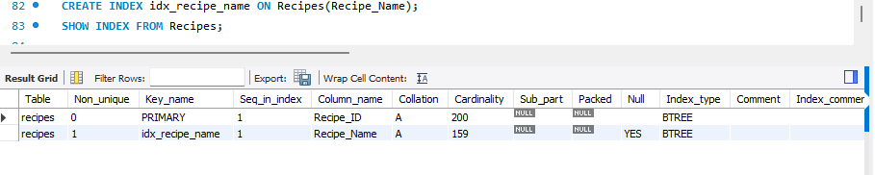

15. Concurrent Access Management (Locking)
Scenario: Two employees are editing the same recipe price simultaneously. How do you prevent data conflict?
- Interpretation: Explaining table or row-level locking during a transaction.
- Query:
SQL
LOCK TABLES Recipes WRITE;
-- Perform Updates --
UNLOCK TABLES;
- Explanation: Locking prevents "Other Level Employees" from modifying the data while a critical update is in progress, ensuring consistency.

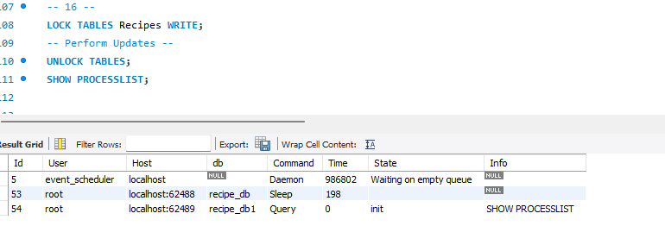

16. Exporting to Web Apps (JSON Functions)
Scenario: A partner website needs our recipe data in JSON format for their API.
- Interpretation: Converting relational table data into a JSON object.
- Query:
SQL
SELECT JSON_OBJECT('id', Recipe_ID, 'name', Recipe_Name, 'rating', Rating)
FROM Recipes
WHERE Recipe_ID = 1; [cite: 18, 40]
- Explanation: Demonstrates modern SQL capabilities where relational data is bridged with web-standard formats like JSON.

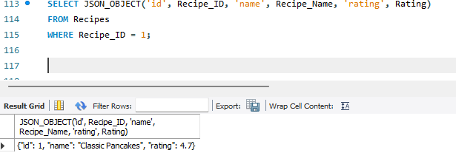

17. Cleaning Inactive Data (DELETE with Subquery)
Scenario: The manager wants to delete all recipes that have 0 reviews and were created over a year ago.
- Interpretation: Combining DELETE with multiple conditions and date functions.
- Query:
SQL
DELETE FROM Recipes
WHERE Review_Count = 0
AND Creation_Timestamp < DATE_SUB(NOW(), INTERVAL 1 YEAR); [cite: 13, 14, 26, 40]
- Explanation: Periodically removing "dead weight" data keeps the database lean and performant.
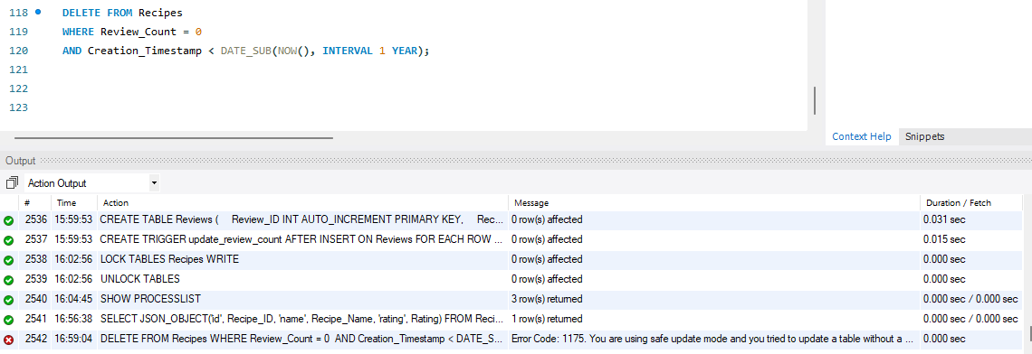
18. Structural Evolution (DDL - ALTER & MODIFY)
Scenario: You realized that the Review_Count might eventually exceed the limit of a standard INT. How do you change it?
- Interpretation: Using Data Definition Language (DDL) to modify existing table structures.
- Query:
SQL
ALTER TABLE Recipes
MODIFY COLUMN Review_Count BIGINT DEFAULT 0; [cite: 25, 40]
- Explanation: Shows how to evolve the database schema without losing existing data.

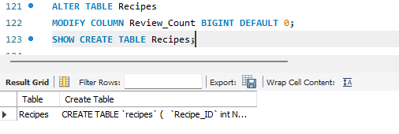

19. Nutrition Density Summary (Aggregation)
Scenario: For each recipe, calculate the "Calorie Density"—total calories divided by servings—and group them by their rating.
- Interpretation: Combines arithmetic operations with GROUP BY and AVG.
- Query:
SQL
SELECT r.Rating, AVG(n.Calories_kcal / r.Servings) AS Avg_Calorie_Density
FROM Recipes r
JOIN Nutrition n ON r.Recipe_ID = n.Recipe_ID
GROUP BY r.Rating
HAVING COUNT(*) > 1;
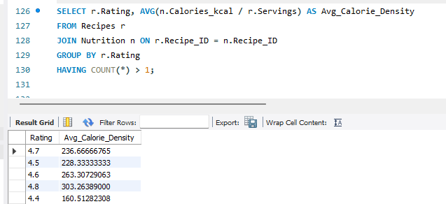

20. Finding Most Ingredient-Heavy Recipes
Scenario: Identify recipes that use more than 6 ingredients.
Interpretation: Use GROUP BY with HAVING to filter aggregated counts.
Query:
SELECT Recipe_ID, COUNT(*) AS Ingredient_Count
FROM Recipe_Ingredients
GROUP BY Recipe_ID
HAVING COUNT(*) > 6;
Explanation: HAVING filters grouped results after aggregation.
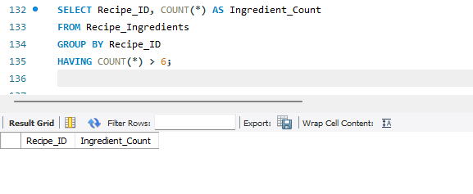
21. Cheapest Recipe Available
Scenario: Find the lowest-priced recipe.
Interpretation: Use MIN() aggregation.
Query:
SELECT Recipe_Name, Price_USD
FROM Recipes
WHERE Price_USD = (SELECT MIN(Price_USD) FROM Recipes);
Explanation: Subquery finds minimum value, outer query retrieves details.

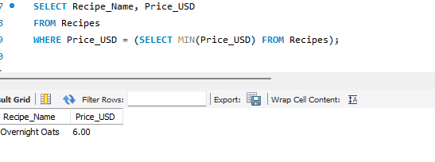

22. Recipes Without Ingredients (Data Error Check)
Scenario: Find recipes that have no ingredients listed.
Interpretation: LEFT JOIN with NULL check.
Query:
SELECT r.Recipe_Name
FROM Recipes r
LEFT JOIN Recipe_Ingredients ri ON r.Recipe_ID = ri.Recipe_ID
WHERE ri.Recipe_ID IS NULL;
Explanation: Detects missing related records
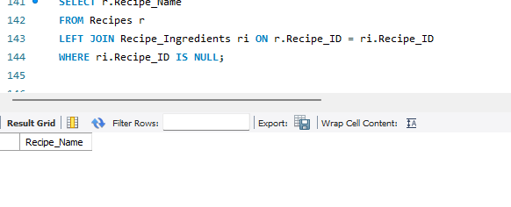

23. Average Cooking Time by Servings
Scenario: Analyze average cooking time based on servings.
Interpretation: GROUP BY Servings.
Query:
SELECT Servings, AVG(Cooking_Time_Mins) AS Avg_Time
FROM Recipes
GROUP BY Servings;
Explanation: Groups recipes and calculates average per category.

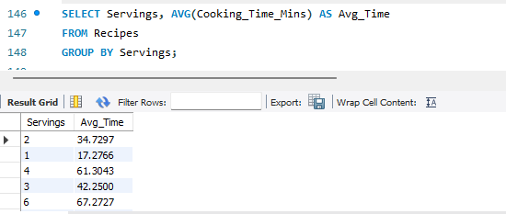

24. Highest Protein Recipe
Scenario: Find recipe with maximum protein.
Interpretation: Join + MAX().
Query:
SELECT r.Recipe_Name, n.Protein_g
FROM Recipes r
JOIN Nutrition n ON r.Recipe_ID = n.Recipe_ID
WHERE n.Protein_g = (SELECT MAX(Protein_g) FROM Nutrition);
Explanation: Identifies top nutritional value.
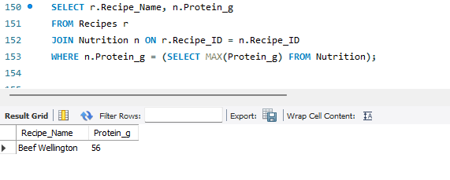
25. Recipes Created This Month
Scenario: Retrieve recipes created in the current month.
Interpretation: Use MONTH() and YEAR().
Query:
SELECT Recipe_Name
FROM Recipes
WHERE MONTH(Creation_Timestamp) = MONTH(CURDATE())
AND YEAR(Creation_Timestamp) = YEAR(CURDATE());
Explanation: Filters by current system date.

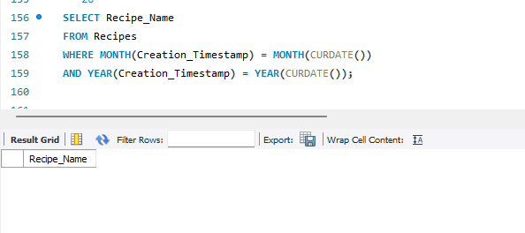

26. Counting Total Ingredients Used
Scenario: Count total ingredient entries in database.
Interpretation: COUNT(*).
Query:
SELECT COUNT(*) AS Total_Ingredients
FROM Recipe_Ingredients;
Explanation: Counts all rows.

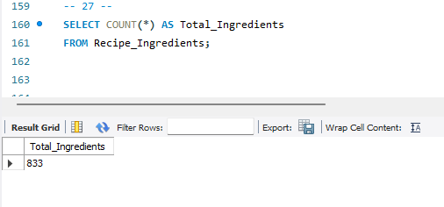

27. Recipes Above Average Price
Scenario: Find recipes costing more than average.
Interpretation: Subquery with AVG().
Query:
SELECT Recipe_Name, Price_USD
FROM Recipes
WHERE Price_USD > (SELECT AVG(Price_USD) FROM Recipes);
Explanation: Compares row with global average.

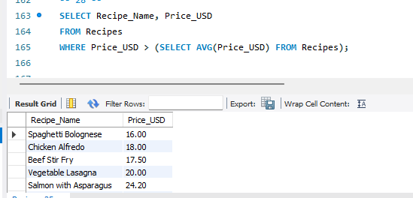

28 . Ingredient Frequency Analysis
Scenario: Find most commonly used ingredient.
Interpretation: GROUP BY + ORDER BY.
Query:
SELECT Ingredient_Name, COUNT(*) AS Usage_Count
FROM Recipe_Ingredients
GROUP BY Ingredient_Name
ORDER BY Usage_Count DESC
LIMIT 1;
Explanation: Frequency analysis.
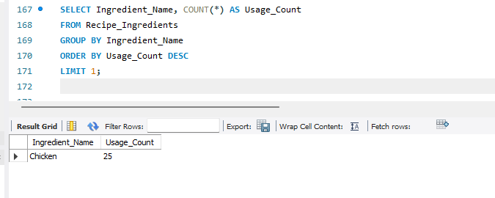

29: The "Inflation Adjustment" Tool
Scenario: The kitchen manager noticed that meat prices have risen by 10%. Instead of manually updating every single recipe price, they want a way to increase prices for a specific category of food by a percentage.
Interpretation: Using a parameterized UPDATE combined with a Subquery and String Concatenation.
Explanation: Create a stored procedure that takes an Ingredient Keyword (e.g., 'Chicken') and a Percentage (e.g., 10.00) and increases the Price_USD of every recipe containing that ingredient.
DELIMITER //

CREATE PROCEDURE AdjustPriceByIngredient(
IN ingredient_name_param VARCHAR(100),
IN percentage_increase DECIMAL(5,2))
BEGIN
UPDATE Recipes
SET Price_USD = Price_USD * (1 + (percentage_increase / 100))
WHERE Recipe_ID IN (
SELECT Recipe_ID
FROM Recipe_Ingredients
WHERE Ingredient_Name LIKE CONCAT('%', ingredient_name_param, '%') );
END //

DELIMITER ;

-- How to use it:
CALL AdjustPriceByIngredient('Chicken', 10.00);

30: The "Health Audit" Report
Scenario: The nutritionist needs to quickly identify if a specific recipe is "High Calorie." Manually checking the Nutrition and Recipes tables for every dish is too slow.
Interpretation: Using a JOIN-based calculation combined with conditional IF/ELSE logic and OUT parameters.
Explanation: Create a stored procedure that takes a Recipe ID and returns a status message. If the calories per serving are greater than 800, it should return "High Calorie"; otherwise, it should return "Standard."
DELIMITER //

CREATE PROCEDURE GetCalorieStatus(
IN r_id INT,
OUT status_msg VARCHAR(50)
)
BEGIN
DECLARE cal_per_serving DECIMAL(10,2);

SELECT (n.Calories_kcal / r.Servings) INTO cal_per_serving
FROM Recipes r
JOIN Nutrition n ON r.Recipe_ID = n.Recipe_ID
WHERE r.Recipe_ID = r_id;

IF cal_per_serving > 800 THEN
SET status_msg = 'High Calorie';
ELSE
SET status_msg = 'Standard';
END IF;
END //

DELIMITER ;

-- How to use it:
CALL GetCalorieStatus(101, @result);
SELECT @result AS Health_Status;

31. Sorting Recipes by Rating and Price
Scenario: Show best-rated cheapest recipes first.
Interpretation: ORDER BY multiple columns.
Query:
SELECT Recipe_Name, Rating, Price_USD
FROM Recipes
ORDER BY Rating DESC, Price_USD ASCExplanation: Priority sorting
